Operational Concept Description (OCD)

Spherical Modeling Tool

Team 13

Robert Lindstrom – Client
Lyle Franklin – Project Manager
Minsuk Heo – Prototyper
Oziel Carneiro – Feasibility Analyst
Sait Ilhaner – IV&V
Guoxiong Xie – Life Cycle Planner
Nikita Vlasenko – OCD
Mehmet Sezer – Requirements Engineer

12/02/2013

Version History
Date | Author | Version | Changes made | Rationale
9/23/13 | NV | 1.0 | - Original for CSCI577; Tailored from ICSM OCD Template | - To fit CS577A, B course content
10/22/13 | NV | 2.0 | - Original for CSCI577; Tailored from OCD 1.0 | - To fit CS577A, B course content
12/02/13 | NV | 2.1 | - Original for CSCI577; Tailored from OCD 2.0 | - To fit CS577A, B course content

Table of Contents
Operational Concept Description (OCD) i
Version History iii
Table of Contents iv
Table of Tables v
Table of Figures vi
1. Introduction 1
2. Shared Vision 2
2.1 Overview of the system 2
2.2 System Boundary and Environment 4
3. System Transformation 5
3.1 Information on Current System 5
3.2 System Objectives, Constraints and Priorities 6
3.3 Proposed New Operational Concept 7
3.4 Organizational and Operational Implications 8

Table of Tables
Table 1: The Program Model 2
Table 2: Capability Goals 2
Table 3: Level of Service Goals 6

Table of Figures
Figure 1: Benefits Chain Diagram 3
Figure 2: System Boundary and Environment Diagram 4
Figure 3: Element Relationship Diagram 8
Figure 4: Business Workflows Diagram X
Figure 5: Business Workflow Diagram of Volunteer Tracking System - Example X

Introduction
This document provides an explanation of the requirements and goals established in the meetings held between the stakeholders of the C60 Sphere Modeling Tool (SMT). It also shows current business workflow and how the system should be organized according to what was established by the communication of the development team with the client. The success-critical stakeholders of the project are Robert Lindstrom as the project owner; Lyle Franklin as the project manager; Minsuk Heo as the prototyper; Oziel Carneiro as the feasibility analyst; Sait Ilhaner as an independent verification and validation engineer IV&V; Guoxiong Xie as the life cycle planner (LCP); Nikita Vlasenko as the operational concept developer (OCD); Mehmet Sezer as the requirements engineer.
The status of the OCD is currently in the valuation phase. No previous OCD documents have yet been developed.

Shared Vision

Overview of the system

Table 1: The Program Model of the SMT
Assumptions
Spherical visualization is an effective tool for data visualization.
There exists a need for spherical visualization
Stakeholders | Initiatives | Value Propositions | Beneficiaries
- Development Team  - Sales manager | - Develop SMT  - Validate usability  - Marketing and sales  - Provide training and support  - Determine distribution model | - Increase comprehension of complex data  - Reveal system efficiencies and deficiencies  - Increase collaboration and communication on teams  - Improves decision making  - Revenue generation | - C60 clients  - C60 itself

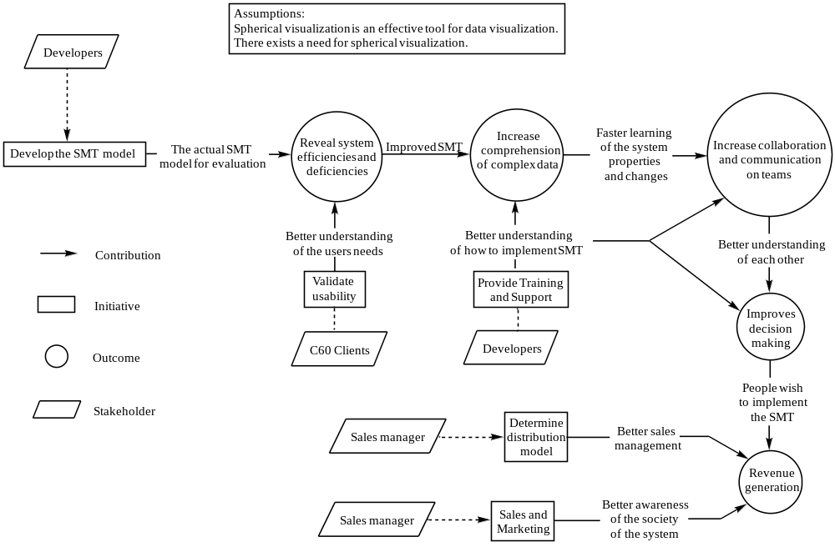

Figure 1: Benefits chain diagram

System Boundary and Environment

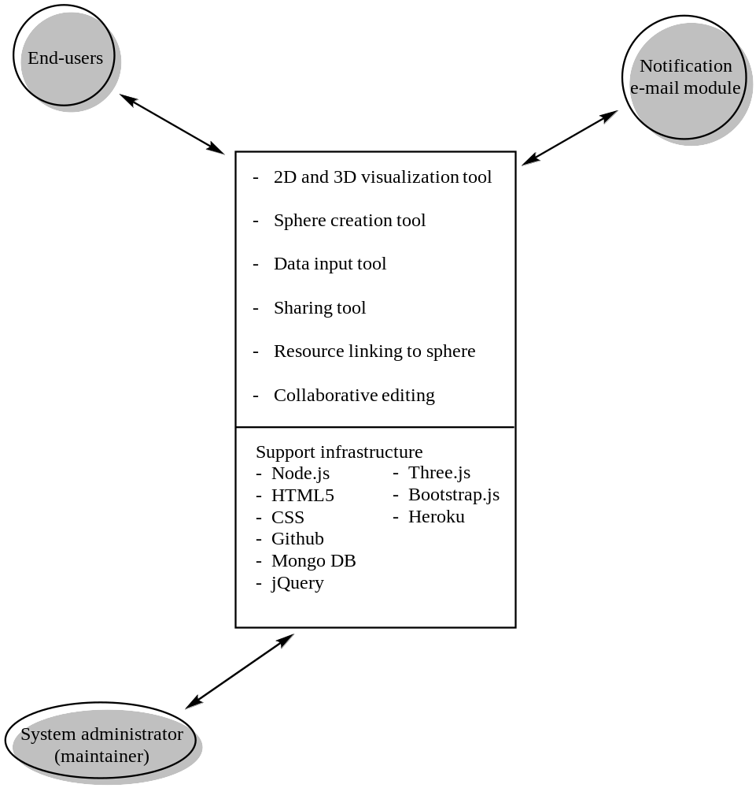

Figure 2: System Boundary and Environment Diagram

System Transformation

Information on Current System

Infrastructure
For the development of the system currently the following is used:
- HTML5
- Java for server-side components
- Javascript with Backbone.js framework for client-side components
- Bootstrap.css and bootstrap.js for design
- Highcharts for chart creation
- Three.js – 3D graphic rendering
- jQuery1.9 for easy coding
- Mongo DB for database part
- Github for version control
- Heroku for hosting services
- Node.js for Creating server-side REST API
It is supposed that the developed system will be usable on web browsers on both desktops and mobile devices

Artifacts
- OCD document. Explains how the system operates, business workflow.
- Prototype. Implements the presumable requirements established during the communication between the team and the client. Helps to clarify what the team needs to do further, clarifies the requirements.
- FED document. Assesses the feasibility of the project, possible obstacles.
- LCP document. Schedule and budget planning
- 2D circle and 3D sphere models. Shows the 2D and respective 3D representations of the system.
- Data input survey, manageable questionnaire. Allows for the modification of the amount of data we need to put in and the data input itself. One of the interface parts.

Current Business Workflow
The system is being developed for the first time and has never been utilized, so no business workflow of the current system exists for today.

Figure 3: Business workflow diagram

System Objectives, Constraints and Priorities

Capability Goals
Capability Goals | Priority Level
OC-1 Sphere Generation | Must have
OC-2 Collaborative editing | Should have
OC-3 Data visualization | Want to have

Level of Service Goals
Table 2: Level of Service Goals
Level of Service Goals | Desired  Level | Acceptance level | Referred WinWin Agreements
2D/3D toggling time | 1 s | 5 s | WC_2496
Response time upon addition of the next sphere and upon editing the existing picture of an assembly of different spheres | 0.1 s | 5 s | WC_2482; WC_2483; WC_2493; WC_2494
Response time upon sphere rotation, editing | 0.02 s | 2 s | WC_2493
Uptime (Heroku) | 99 | 90 | WC_2780

Organizational Goals
OG-1: Increase comprehension of complex data via 3D visualization
OG-2: Reveal system efficiencies and deficiencies through the end-users interaction with the system
OG-3: Increase collaboration and communication on teams via 3D rendering and data sharing
OG-3: Improves decision making via 3D rendering and easy data sharing
OG-4: Increase revenue via increased demand of the system (or widespread need for the system)

Constraints
CO-1: Monetary budget: The customer is willing to pay for NDI/NCS but no more than $35 per month for hosting and $9 per month for database.
CO-2: Schedule: Need to deliver the system by the end of the second semester

Relation to Current System
The system is being developed for the first time: no current system yet exists, so no comparisons can be made.

Proposed New Operational Concept

Element Relationship Diagram
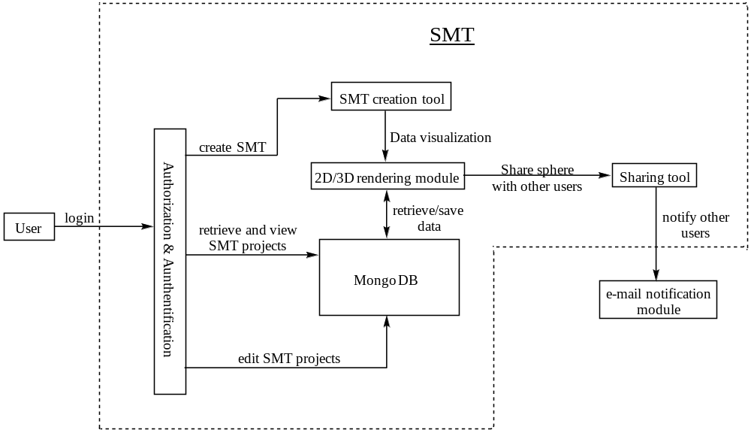

Figure 3: Element Relationship Diagram of Spherical Modeling Tool (SMT)

Business Workflows
Since the system is being developed for the first time, no business workflow yet exists.

Organizational and Operational Implications

Organizational Transformations
No organizational transformation have yet been needed

Operational Transformations
No changes in the workflows can be identified right now, since no workflows exist for the current system which is under the development.

